Viva 2

**Question 2.**

**Aim:** Create a Skyscraper using Blender.

**Steps Used:**

1. Open Blender, and clear everything from the interface which is as of now there.
2. Create another extend and get out the screen, i.e., Delete the default block.
3. Start with adding a plane to go likely as the base.
4. Now, add a solid shape and scale it to seem as though a cuboid (rule structure of the structure).
5. Now, fly and scale it and position it on one of the sides of the base 3D square (to address n windows).
6. Set the outside of the plane tending to windows to Glass BSDF to give a glass-like impact.
7. Add the plane tending to windows as demonstrated by the size of the base shape.
8. Do indistinguishable from in a condition of congruity 5 to all the sides of the shape.
9. Now pick the front side of the structure, make another plane, and scale and fix it at the lower a bit of the base shape tending to the section of the structure.
10. Fill shadings in all the shapes as shown by your decision

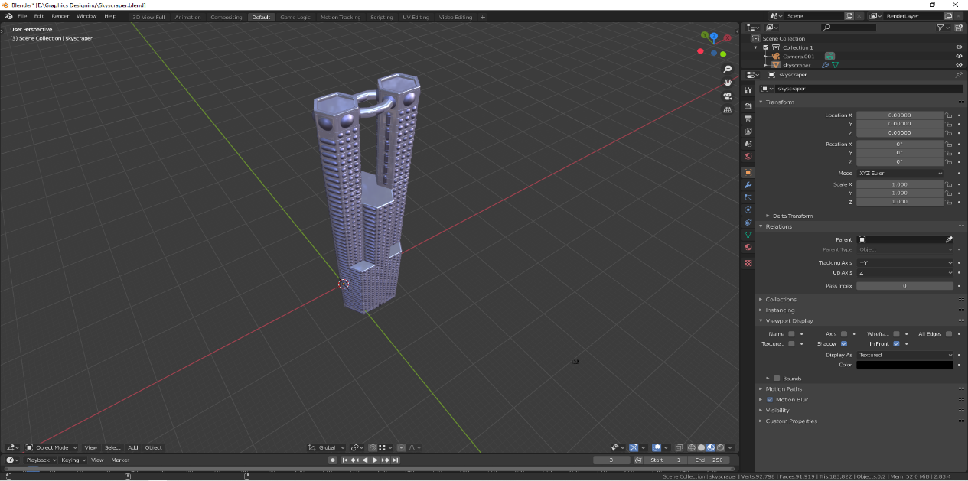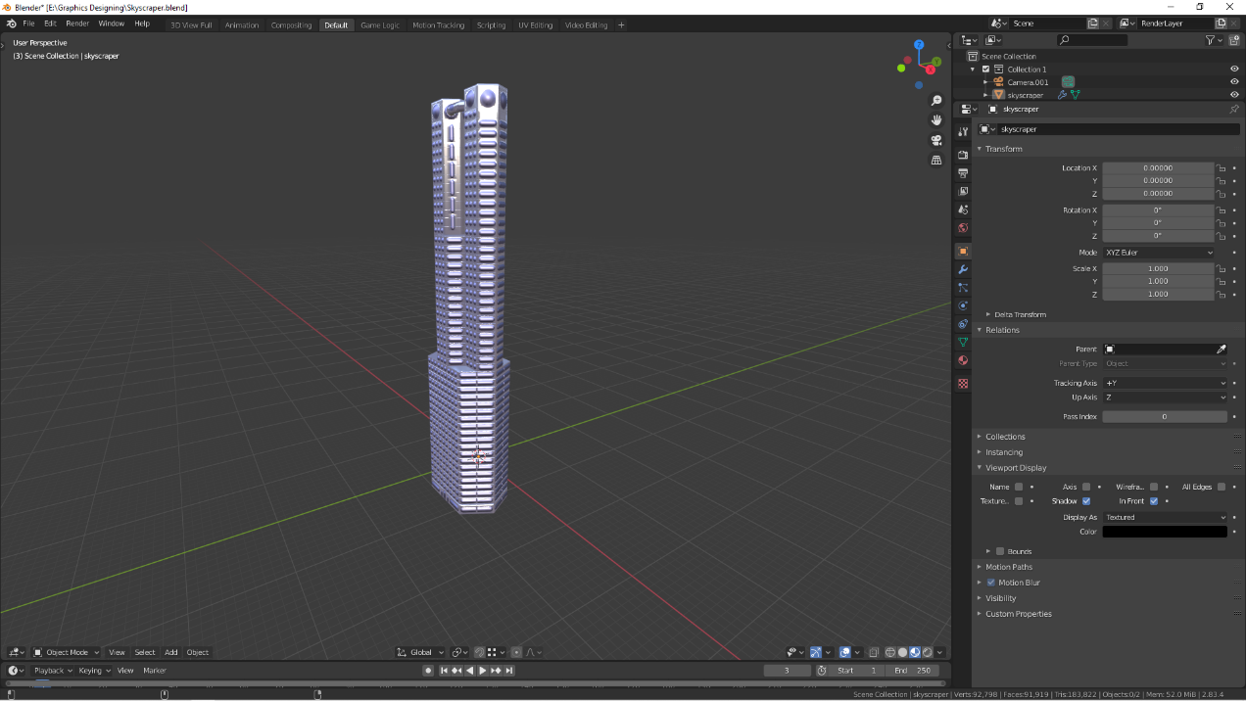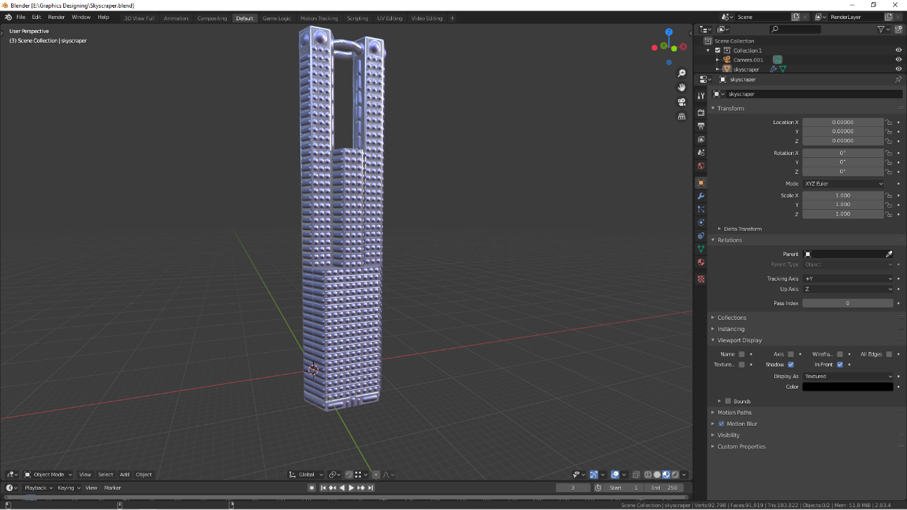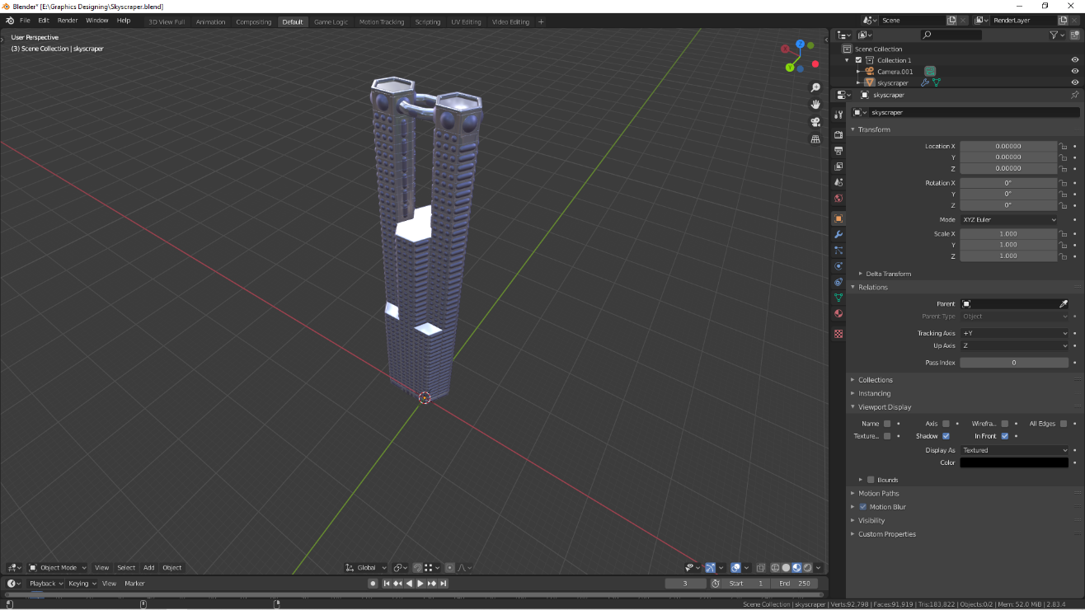

**Question 1.**

**Steps Used:**

1. Open GIMP.

2. Inside the gimp, make another layer with white foundation (1056x701 px).

3. Open a picture of a mountain as layers in GIMP and make another straightforward

layer to draw limits.

4. Use the 'Ways device' over the picture and start choice limits and design of the

picture.

5. After determination of format/limits, go to 'Select', browse 'Way' alternative and

your way will be chosen.

6. After way is chosen click on 'basin fill apparatus' from the toolbar and shading the

mountain with your ideal tone.

7. Repeat stages 3,4,5 for making the grass, stream and sky of the scene.

8. Structure of the mountain scene is finished.

9. Use your imagination to style the snow cap and when you feel it's acceptable, at that

point place it at the highest point of the mountain range.

10. For adding the snowfall impact, add another layer of dark tone over all the layers

and set the photograph impact from typical to the screen.

11. Go to Filters - > Noise - > RGB Noise and afterward press 'alright', this will add some

clamour to the picture and make it clear.

12. Again, Go to Filters - > Blur - > Pixelized and afterward press 'alright', this will make

commotion impact pixelized.

13. Then, Go to Filters - > Blur - > Motion Blur and afterward press 'alright'.

14. After finishing the above advances, Go to Colours - > Levels and change the white

and dark info levels till you find pixelated snow impact over your picture.

